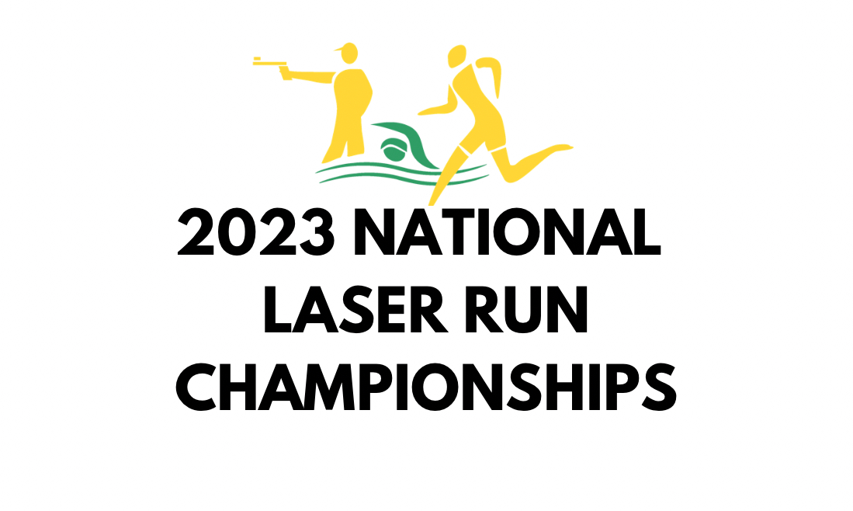

10th & 11th June 2023

Bankstown, NSW

Bankstown

Invitation Letter

Timetable

Date & Time | Event | Location
SATURDAY 10th JUNE -
1:00 PM - 4:30PM | Informal ‘laser run’ relay and come and try / BBQ | TBC – will be close to Bankstown/Georges Hall
SUNDAY 11th June
9:00 AM | Registration & Warm up available | Bankstown Sports Athletics Club  McClean St  Georges Hall NSW 2198
10:00 AM – 1:00PM | Laser Run championship
11:30AM – 1:00PM (approx.) | Laser Run ‘novice’ event (5m)
1:00PM – 1:30PM | Presentation
2:00PM – 3:30PM | OCR introduction / ‘come and try’ | Ninja Warrior Western Sydney, 19/380 Marion Street, Condell Park NSW 2200

Competition Format

LASER-RUN AGE SPECIFIC DISTANCES
Category | Age | Running sequence | Shooting sequence | Distance
Under 11 | 10 and younger  (2013 or later) | 2 X 300 | 2 X 5 hits (two hands) | 5m
Under 13 | 11-12  (2011-2012) | 3 X 300 | 3 X 5 hits | 5m
Under 15 | 13-14  (2009-2010) | 3 X 600 | 3 X 5 hits | 5m
Under 17 | 15-16  (2007-2008) | 4 X 600 | 4 X 5 hits | 10m
Under 19 | 17-18  (2005-2006) | 5 X 600 | 4 X 5 hits | 10m
Juniors | 19-21  (2002 or earlier) | 5 X 600 | 4 X 5 hits | 10m
Seniors | 22 +  (2001+) | 5 X 600 | 4 X 5 hits | 10m
Masters 30+, 40+, 50+ | 30+, 40+ & 50+  60+ | 3 X 600  2 X 600 | 3 X 5 hits  2 X 5 hits | 10m  5m

LASER RUN PROCEDURE

- The Laser Run begins with a pack start. The 15-minute warm-up finishes 3 minutes prior to the start of the competition.
- The Laser Run competition is a continuous series of shooting and running sequences. The number of sequences is dependent on age (please refer to the table above).
- The shooting sequence requires the athlete to shoot five times within their target’s valid zone (diameter 59.5mm) within 50 seconds after firing the first shot in that sequence. An unlimited number of attempts at the target may be made in that time. The athlete may start running as soon as they have landed five shots within the valid zone. If 50 seconds elapses without five shots having landed in the valid zone, , the athlete may start running on receiving a signal from the shooting judge.
- Athletes are responsible for shooting on the correct target.
- Athletes must stand with both feet on the ground, without support, completely within the shooting station. The entire pistol must be held and shot with one hand only, except in the Under 11 age category. The unarmed hand must not give support to the arm or hand in which the pistol is held.
- Athletes must touch the laser pistol to the table between each shot.
- A warning will be given for the first offence. A time penalty will apply for a subsequent offence.
- Athletes must continue attempting to hit the target until they have landed 5 shots in the valid zone or 50 seconds has elapsed, otherwise they will incur a 10 second’ penalty to be given at the shooting range before proceeding with the next running sequence.
- Athletes must follow the designated course from crossing the start line, going to the shooting range for each shooting series and, having completed the required number of shooting and running sequences according to their age category, crossing the finish line.
- If informed by a Judge and/or announced by the sound system, the athlete must stop and remain in the Last Penalty Stop Area for the time indicated.
- The Last Penalty Area will be located halfway between the shooting range and the finish line.
- During the race no athlete may accept any physical assistance or refreshment.
- The athlete must complete the course by crossing over the finishing line to register a finish time.
- Athletes will be timed and placed in the order in which any part of their torso (as distinguished from the head, neck, arms, legs, hands or feet) reaches the vertical plane of the nearer edge of the finish line.
- Athletes must complete the full number of shooting and running sequences relevant to their age.
- The competition result will be based on the competing time of the athletes, the fastest is ranked better.

General Competition Information
The timetable is subject to change pending entry numbers.

A draw with specific heat times, warm up times and entrants will be released in the week leading up to the competition.

The competition will be carried out according to UIPM Rules. The Laser Run Championships will take place on Sunday, 11th June 2023.
Laser Run: Up to 10+2 shooting range with Ecoaims LT600 Hit/Miss Laser Targets.
Running Course: Flat, grass surface, may cross synthetic track

Competition Venue
The main event will take place at Bankstown Sports Athletics Club (McClean St, Georges Hall NSW 2198).
Please note that the laser run event will be followed by a ‘come and try’ laser run opportunity for new athletes (aged 10 and over).

INFORMAL BBQ AND LASER RUN RELAY EVENT – SATURDAY AFTERNOON
We would like to create the opportunity for our community to get together outside the competition arena, and to give parents, supporters and new athletes a fun taste of laser running with a novelty ‘laser tag’ event (including a relay) and an opportunity to learn how to use a laser pistol, ahead of the laser run novice event on Sunday. We are in the process of booking an outdoor park venue close to the Bankstown Athletics Club.
MPA will provide BBQ facilities and a range of bread, sauce and pre-made salads for a nominal charge – please BYO meat and drinks. If you would like to be included for catering purposes, please note this on the entry form, including numbers so we can cater accordingly.

INTRODUCTION TO OBSTACLES – SUNDAY AFTERNOON
We have made a group booking for Sunday afternoon at Ninja Warrior Bankstown. We will have the course to ourselves for 90 minutes and professional instructors to take you through the fundamentals. Numbers may be limited, so please indicate your interest on the entry form. Priority will be given to athletes who competed at the National Pentathlon Championships in Melbourne in April or the MPV State Pentathlon Championships in March.

MEMBERSHIP

To be eligible to enter, athletes must:
- hold current membership with Modern Pentathlon Queensland, Modern Pentathlon Victoria, Modern Pentathlon Association of NSW or Modern Pentathlon Association of Western Australia;
- be registered with another UIPM-recognised national pentathlon federation; or
- purchase a ‘day membership’ with MPA, where indicated on the entry form.

GENERAL INFORMATION

- All athletes are kindly requested to wear their state, club or hub official uniform or generic attire. National uniforms (AUS only) should not be worn at the competition.
- Expected Weather conditions: Average daily temperature 17 degrees Celsius

LOC CONTACT DETAILS

Please directly contact the Event Administrator for local information regarding family and friends wishing to attend the competition or for any local questions you may have.

EVENT ADMINISTRATOR: MODERN PENTATHLON AUSTRALIA
Kim Richardson
pathways@modernpentathlon.org.au

We are looking forward to seeing our Modern Pentathlon Community in Sydney in June.
Train well,

Maki Takken
MPA President

